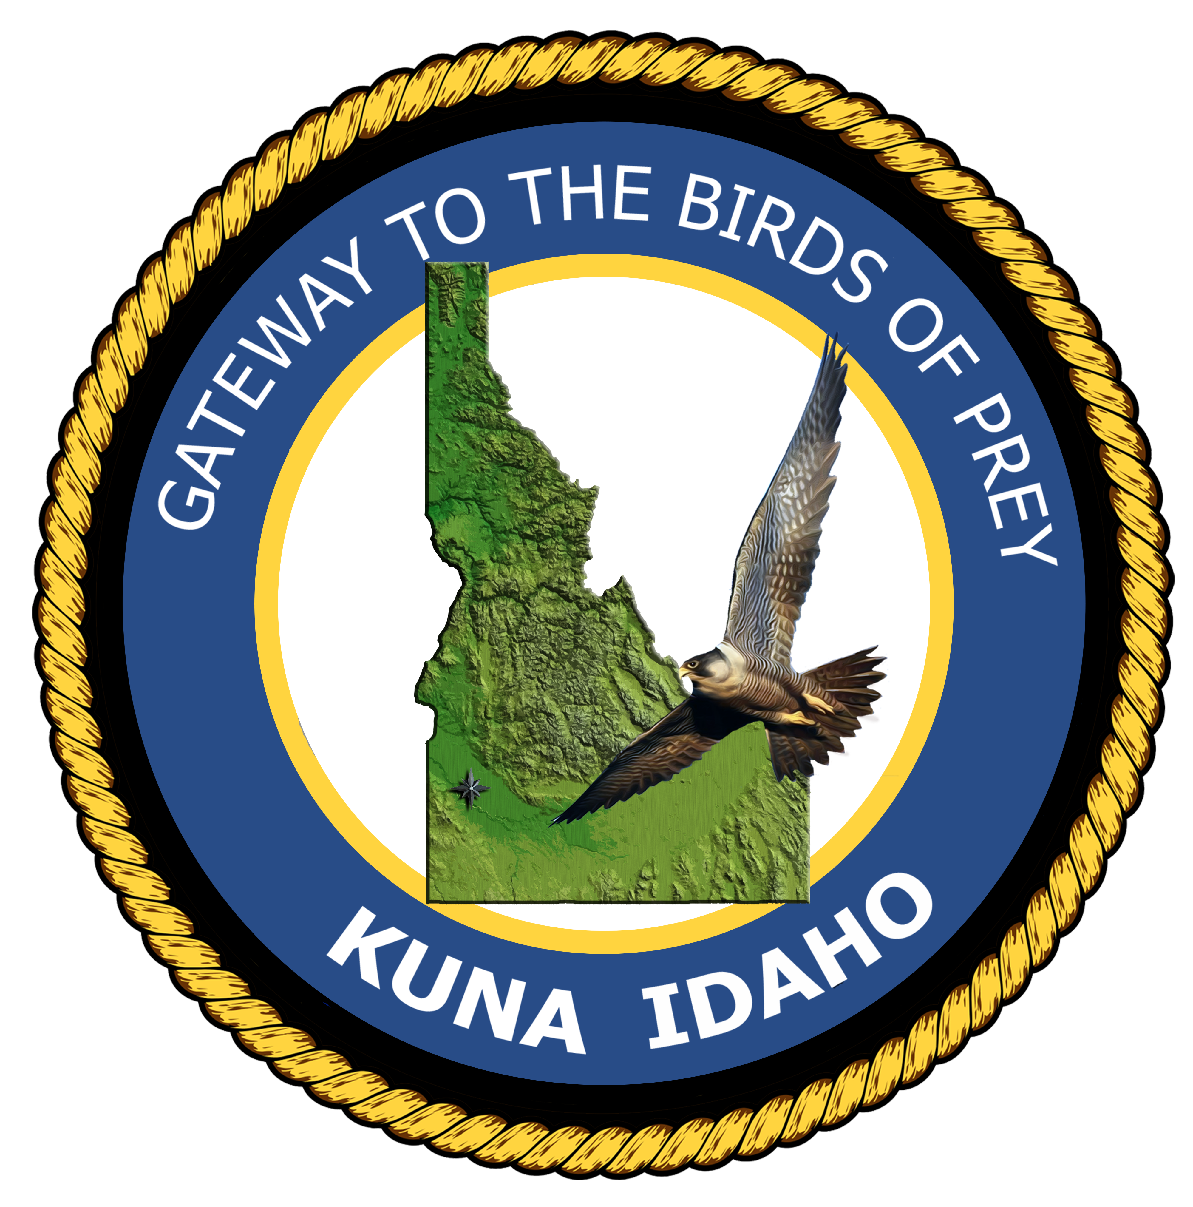
CITY OF KUNA

Kuna City Hall Council Chamber, 763 W. Avalon Street, Kuna, Idaho

Park Impact Fee Committee Meeting

AGENDA

Thursday, February 11, 2016
6:00 p.m.

- Call to Order and Roll Call

- Business:

  - Approve PIFC Meeting Minutes: November 12, 2015

  - Presentation of Park Impact Fee breakdown – Bobby Withrow, Parks Director

  - Discussion and questions of proposed Park Impact Fee Ordinance– Richard Roats, City Attorney

3. Adjournment:

